PROJECT REPORT
Implement Client Script & UI Policy (Incident)
ServiceNow System Administrator – Micro Project
Team ID | SWTID-2026-9505
Date | 3 OCTOBER 2026
Project Title | Implement Client Script & UI Policy (Incident)
Platform | ServiceNow

Project Report Format
1. INTRODUCTION
1.1 Project Overview
1.2 Purpose
2. IDEATION PHASE
2.1 Problem Statement
2.2 Empathy Map Canvas
2.3 Brainstorming
3. REQUIREMENT ANALYSIS
3.1 Customer Journey Map
3.2 Solution Requirement
3.3 Data Flow Diagram
3.4 Technology Stack
4. PROJECT DESIGN
4.1 Problem Solution Fit
4.2 Proposed Solution
4.3 Solution Architecture
5. PROJECT PLANNING & SCHEDULING
5.1 Project Planning
6. FUNCTIONAL AND PERFORMANCE TESTING
6.1 Performance Testing
7. RESULTS
7.1 Output Screenshots
8. ADVANTAGES & DISADVANTAGES
9. CONCLUSION
10. FUTURE SCOPE
11. APPENDIX
Source Code
Dataset Link
GitHub & Project Demo Link

1. INTRODUCTION

1.1 Project Overview
This project, Implement Client Script & UI Policy (Incident), is a ServiceNow micro project that improves the behaviour of the Incident form and Incident list. It combines a UI Policy (with a UI Policy Action) and three Client Scripts – onChange, onSubmit and onCellEdit – to automate field behaviour, enforce mandatory data and stop incorrect updates before they reach the database.
The solution works around the Impact field of an Incident. When Impact is set to High, the Urgency field is automatically set to High and becomes read-only, the Assigned To field becomes mandatory at the time of saving, and the State field cannot be changed through list editing. The project was built in six milestones, covering configuration, scripting and end-to-end testing.

1.2 Purpose
The purpose of the project is to maintain clean, consistent and reliable Incident data in ServiceNow by applying client-side controls. Specifically, the project aims to:
- Automatically set Urgency to High when an Incident has High Impact, reducing manual effort and mistakes.
- Make the Urgency field read-only for High-impact incidents using a UI Policy Action.
- Prevent saving a High-impact Incident when the Assigned To field is empty.
- Block direct State changes made through list editing, so that State is updated only from the Incident form.
- Demonstrate good practice in using UI Policies and Client Scripts together on the Incident table.

2. IDEATION PHASE

2.1 Problem Statement
In many ServiceNow instances, Incident records are created and updated quickly by multiple users. Without controls on the form, high-impact incidents are often saved without an owner, urgency is left inconsistent with impact, and the State of an incident is changed casually from the list view. This leads to poor data quality, missed escalations and delays in resolution.
Aspect | Description
I am | A ServiceNow administrator / incident manager responsible for the quality of Incident data.
I'm trying to | Make sure high-impact incidents are always assigned, treated with high urgency and updated in a controlled way.
But | Users can save High-impact incidents without an owner, leave Urgency inconsistent and change State from the list view.
Because | The Incident form has no client-side rules to react to the Impact field or validate data before saving.
Which makes me feel | Concerned that critical incidents may be missed or mishandled, and that reports built on this data are unreliable.

2.2 Empathy Map Canvas
Quadrant | Observations
Says | "High-impact incidents keep getting saved without an owner."  "Urgency does not match the impact."
Thinks | Simple automation on the form can prevent most data-entry mistakes. Controls should be light and not slow users down.
Does | Creates and edits incidents from the form and list; sets Impact, Urgency, Assigned To and State; reviews reports for inconsistent data.
Feels | Frustrated by repeated manual corrections; worried about SLA breaches; confident when the form guides the user.
Pains | Missing assignee, mismatched urgency/impact, accidental State changes in list view, rework.
Gains | Consistent data, faster triage of critical incidents, fewer corrections, better reporting and user confidence.

2.3 Brainstorming
The team brainstormed ways to control Incident behaviour on the client side and shortlisted the following ideas:
Idea | Description | Decision
UI Policy – High Impact Control | Apply field rules on the Incident form when Impact = 1 - High | Selected
UI Policy Action – Urgency | Make the Urgency field read-only for high impact | Selected
onChange Client Script | Auto-set Urgency to High when Impact changes to High | Selected
onSubmit Client Script | Stop saving if Assigned To is empty for High impact | Selected
onCellEdit Client Script | Block State edits from the list view | Selected
Business Rule (server side) | Re-validate on the server | Kept for future scope
Email notification on High impact | Notify assignment group automatically | Kept for future scope

3. REQUIREMENT ANALYSIS

3.1 Customer Journey Map
Stage | User action | Experience / pain point | Solution provided
Open incident | Opens a new or existing Incident form | Fields behave the same irrespective of impact | UI Policy applies when Impact is High
Set Impact | Selects Impact = 1 - High | Must remember to raise Urgency manually | onChange script sets Urgency to High and shows an info message
Edit fields | Tries to change Urgency | Urgency can become inconsistent | UI Policy Action makes Urgency read-only
Save | Clicks Submit / Update | Incident saved with no owner | onSubmit script shows an error and stops the save
List view | Double-clicks State in the list | Accidental State change | onCellEdit script shows an alert and blocks the edit
Resolve | Reverts Impact or completes assignment | Controls remain active unnecessarily | Reverse if false restores fields; save succeeds when valid

3.2 Solution Requirement
Functional requirements
- FR-1: Create a UI Policy named High Impact Control on the Incident table with condition Impact is 1 - High.
- FR-2: Add a UI Policy Action on the Urgency field to make it read-only, with Reverse if false enabled.
- FR-3: Create an onChange Client Script on the Impact field that sets Urgency to 1 (High) and shows an information message.
- FR-4: Create an onSubmit Client Script that prevents saving when Impact is High and Assigned To is empty.
- FR-5: Create an onCellEdit Client Script on the State field that blocks list edits and displays an alert.
- FR-6: Allow State to be updated from the Incident form.
Non-functional requirements
- Lightweight scripts with no noticeable delay in form load or save.
- Clear and meaningful messages for the user.
- Easy to maintain and extend by a ServiceNow administrator.
- Works with a ServiceNow instance with administrative or configuration access.

3.3 Data Flow Diagram
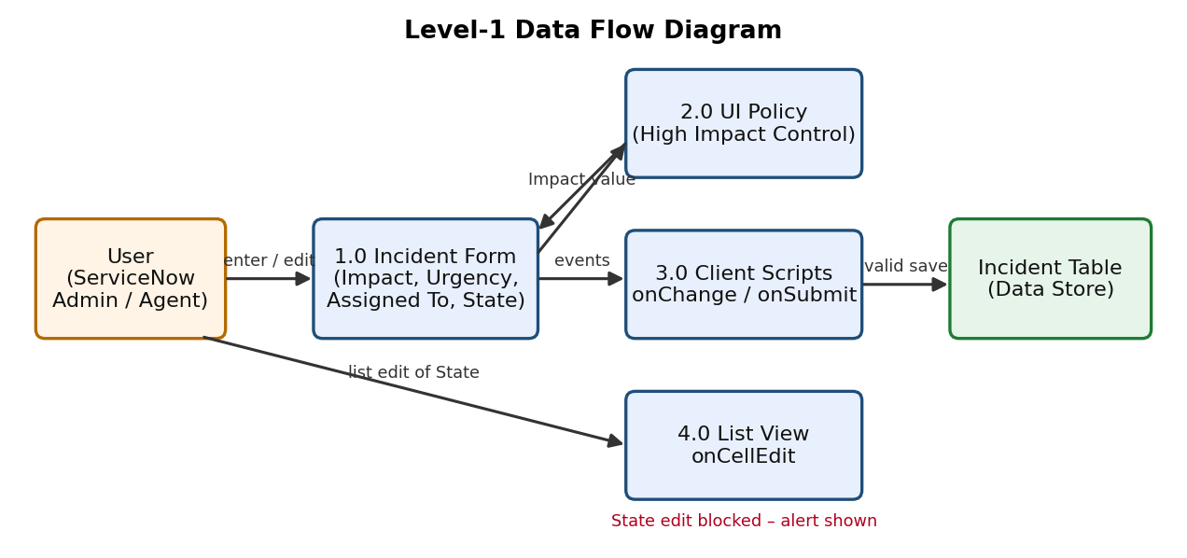
Figure 1: Data flow of the Incident form, UI Policy, Client Scripts and list view

3.4 Technology Stack
Component | Technology
Platform | ServiceNow (Now Platform) instance
Application / Table | Incident [incident]
Configuration | System UI > UI Policies and UI Policy Actions
Scripting | Client Scripts (JavaScript) using the g_form API – onChange, onSubmit, onCellEdit
Learning / project portal | SkillWallet (project workspace and milestone tracking)
Client | Web browser (Windows)

4. PROJECT DESIGN

4.1 Problem Solution Fit
Problem | Solution
High-impact incidents saved without an assignee | onSubmit Client Script makes Assigned To mandatory when Impact is High
Urgency not aligned with Impact | onChange Client Script auto-sets Urgency to High
Urgency edited inconsistently | UI Policy Action makes Urgency read-only
State changed accidentally from list | onCellEdit Client Script blocks list editing of State

The solution fits the problem because every issue occurs on the user's screen, so client-side controls give immediate feedback, are quick to build and need no changes to the database structure.

4.2 Proposed Solution
The proposed solution is a set of four cooperating configurations on the Incident table:
Component | Type / Trigger | Behaviour
High Impact Control | UI Policy (Impact is High) | Applies controls on the Incident form; Reverse if false undoes them when Impact is not High
Urgency action | UI Policy Action | Urgency becomes read-only when the policy condition is met
Auto set urgency for high impact | onChange on Impact | Sets Urgency = 1 and shows "Urgency set to High for High impact incident."
Prevent save if Assigned To missing | onSubmit | Shows an error on Assigned To and returns false, blocking the save
Prevent state change via list edit | onCellEdit on State | Shows an alert and calls callback(false) to cancel the edit

4.3 Solution Architecture
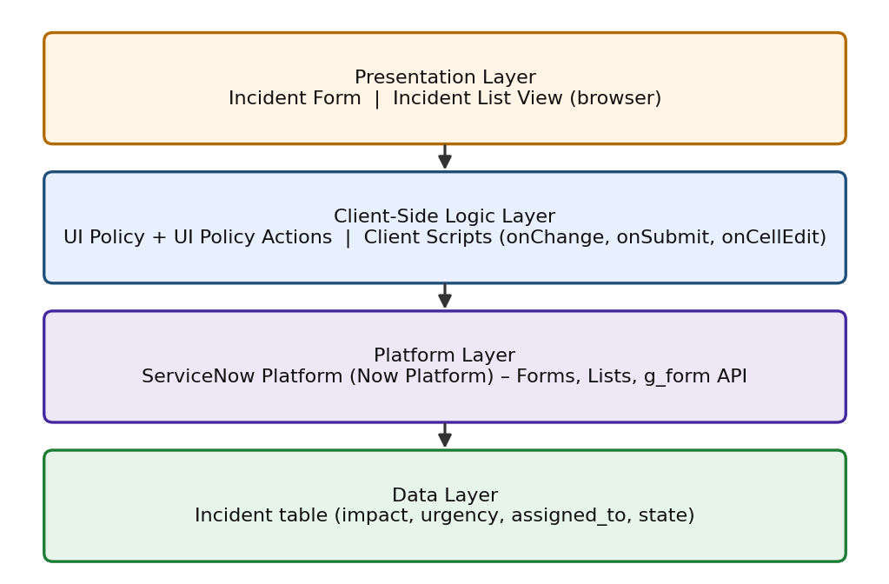
Figure 2: Layered solution architecture

5. PROJECT PLANNING & SCHEDULING

5.1 Project Planning
The project was planned as six milestones followed by a conclusion, with activities distributed among the team members. All milestones are tracked in the SkillWallet project workspace.
Milestone | Activities | Priority | Status
1. Create UI Policy on Incident | Create UI Policy (High Impact Control) | High | Completed
2. Create UI Policy Action – Urgency | Configure Urgency field (read-only) | High | Completed
3. Create onChange Client Script | Auto set urgency for high impact | High | Completed
4. Create onSubmit Client Script | Save validation – Assigned To mandatory | High | Completed
5. Create onCellEdit Client Script | Prevent state change via list edit | Medium | Completed
6. Testing the Configuration | Test mandatory enforcement, successful save, reverse condition, list edit blocking, form-based update | High | Completed
Conclusion | Summarise outcomes and learnings | Medium | Completed

6. FUNCTIONAL AND PERFORMANCE TESTING

6.1 Performance Testing
The configuration was tested in Milestone 6 with five test activities on the Incident form and list view. Each test compared the expected behaviour with the actual behaviour observed in the ServiceNow instance.
ID | Test case | Steps | Expected result | Result
TC-1 | Mandatory enforcement | Open a new Incident, set Impact = High, leave Assigned To empty, click Submit | Save is blocked and an error is shown on Assigned To | Pass
TC-2 | Successful save | Select a user in Assigned To and click Submit | Incident saves; Urgency auto-set and read-only; list restriction still active | Pass
TC-3 | Reverse condition | Open a High-impact incident, change Impact to Medium, click Update | Assigned To not mandatory; Urgency editable again; save succeeds | Pass
TC-4 | List edit blocking | In the Incident list, double-click the State field and try to edit | Alert shown; State value unchanged | Pass
TC-5 | Form-based update | Open the Incident form, change State, click Update | State saves successfully; other rules continue to work | Pass

Summary: all 5 test cases passed (100%). The scripts are small client-side functions, so form behaviour is immediate and no performance degradation was observed during testing.

7. RESULTS

7.1 Output Screenshots

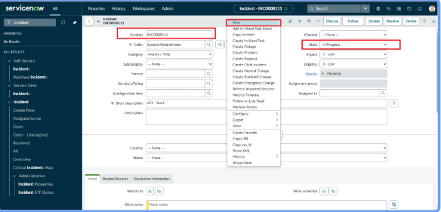
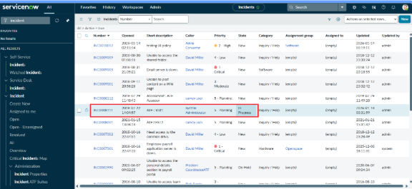

8. ADVANTAGES & DISADVANTAGES
Advantages
- Improves data quality and consistency of Incident records.
- Gives immediate feedback to users without a server round trip.
- Enforces mandatory fields only when needed (High impact).
- Lightweight, easy to implement and maintain.
- Reverse if false keeps the form flexible when conditions change.
Disadvantages
- Client-side controls can be bypassed by imports, integrations or APIs unless server-side rules are added.
- Scripts are tied to the Incident table and must be updated when requirements change.
- Controls apply to the standard UI; other interfaces (e.g. mobile or portal) may need separate checks.
- The list-edit block applies to all users, which may be restrictive for some roles.

9. CONCLUSION
The Implement Client Script & UI Policy (Incident) micro project shows how UI Policies and Client Scripts can work together to enforce dynamic form behaviour, automate field updates and prevent incorrect data submission on Incident forms. By using onChange, onSubmit and onCellEdit scripts together with UI Policy Actions, the project ensures that fields such as Assigned To and Urgency respond correctly to changes in Impact, maintaining clean and consistent data. The solution is lightweight, efficient and easy to implement, making it ideal for short-duration micro-projects while demonstrating good practices for improving form usability and data integrity in ServiceNow.

10. FUTURE SCOPE
- Add server-side Business Rules or Data Policies so the same rules apply to imports and integrations.
- Extend the controls to Priority, Category and Assignment Group.
- Use role-based conditions so only selected roles are restricted from list editing.
- Send automatic notifications to the assignment group for High-impact incidents.
- Apply the approach to other tables such as Problem, Change and Service Request.
- Add dashboards to track High-impact incidents and data-quality metrics.

11. APPENDIX

Source Code
Client Script 1 – Auto set urgency for high impact (Type: onChange, Table: Incident, Field: Impact)
function onChange(control, oldValue, newValue, isLoading) {
if (isLoading || newValue === '') {
return;
}

if (newValue == '1') {
g_form.setValue('urgency', '1');
g_form.addInfoMessage('Urgency set to High for High impact incident.');
}
}

Client Script 2 – Prevent save if Assigned To is missing (Type: onSubmit, Table: Incident)
function onSubmit() {
if (g_form.getValue('impact') == '1' &&
g_form.getValue('assigned_to') == '') {
g_form.showErrorBox(
'assigned_to',
'Assigned To is mandatory for High Impact incidents.'
);
return false;
}
return true;
}

Client Script 3 – Prevent state change via list edit (Type: onCellEdit, Table: Incident, Field: State)
function onCellEdit(sysIDs, table, oldValues, newValue, callback) {
alert('State cannot be updated using list editing. Please open the Incident.');
callback(false);
}

Dataset Link
Not applicable – this project is a configuration project on the ServiceNow Incident table and does not use an external dataset.

GitHub & Project Demo Link
GitHub: [add your repository link here]
Project Demo: [add your demo link here]

